**Task-2**

**Write the blog on the difference between document and window objects**

The document object represents a web page that is loaded in the browser. By accessing the document object, we can access the element in the HTML page. With the help of document objects, we can add dynamic content to our web page. The document object can be accessed with a window.document or just document. And we can create some changes in document.

Example:

* Add, change, and remove any of the HTML elements and attributes
* Change any of the CSS styles
* React to all the existing events
* Create new events

DOM tree structure

A Document Object Model (DOM) tree is a hierarchical representation of an HTML or XML document. It consists of a root node, which is the document itself, and a series of child nodes that represent the elements, attributes, and text content of the document. Each node in the tree has a parent node, except for the root node, and can have multiple child nodes.

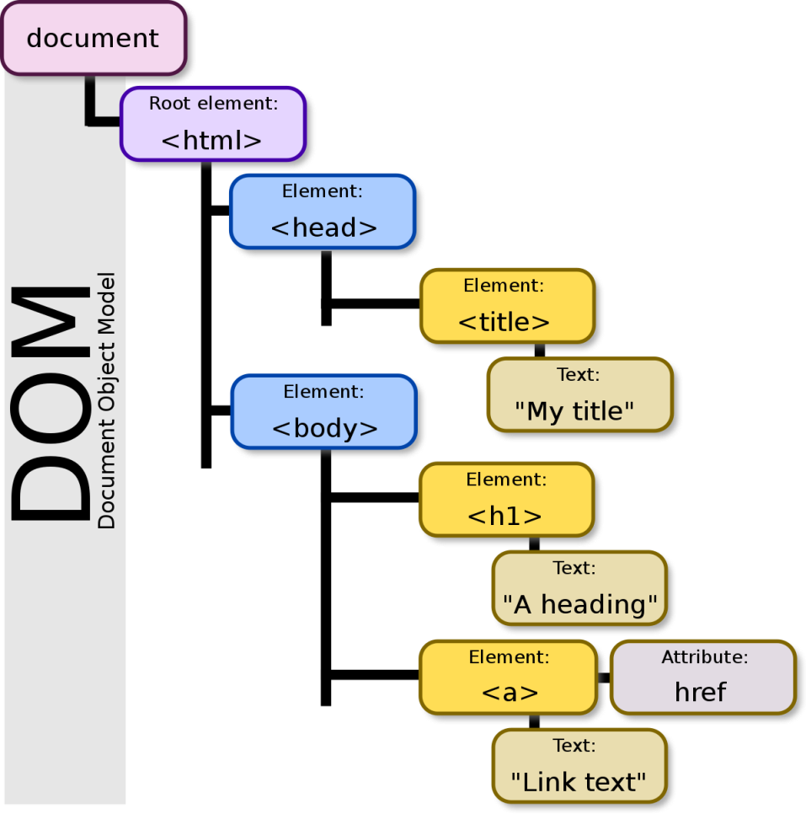

**Window object**

This is a Global object, which has several objects, attributes and functions within it. It can be described as an object with a lot of meta data and data about your webpage. It also contains the document object which is popularly used.

The window object represents a window/tab containing a DOM document, were as document object is property of window object that points to the DOM document loaded in that window.

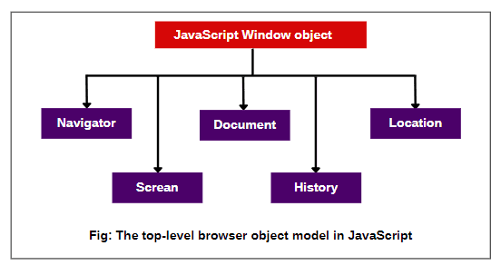

The other major difference is that both window object and document object have properties and methods. Few method names are same in both objects but with different behavior.